

**School of computer application**

CA Third

of

Linux and Shell Scripting (CAP 454)

**Session 2022-2024**

**Submitted to: Submitted by:**

Name: Dr. Devendra Kumar Name: Satyam Mishra

(Dept of. Computer Science) Reg. no: 12212256

Course: MCA

**Department of computer Science**

**Lovely Professional University Jalandhar Punjab (144401)**

**India.**

**Ans. 1**

Step 1: We create two files named file1 and file2 respectively.

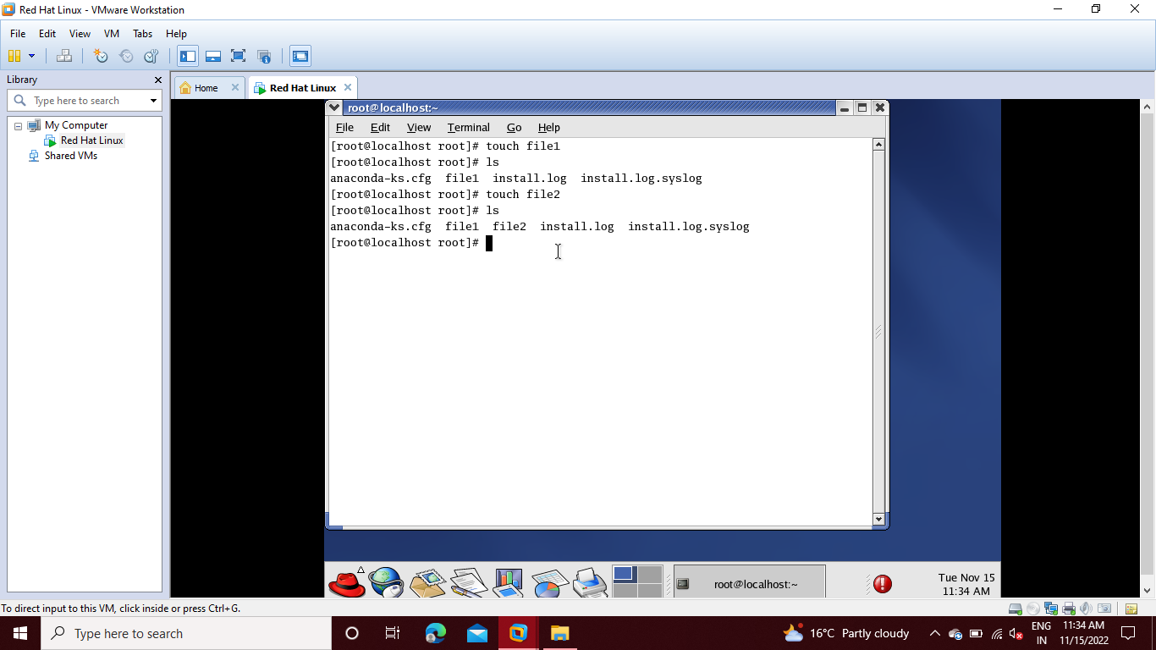

Step 2: Then we archive both files in folder combine using following command :

tar –cvf combine.tar file1 file2

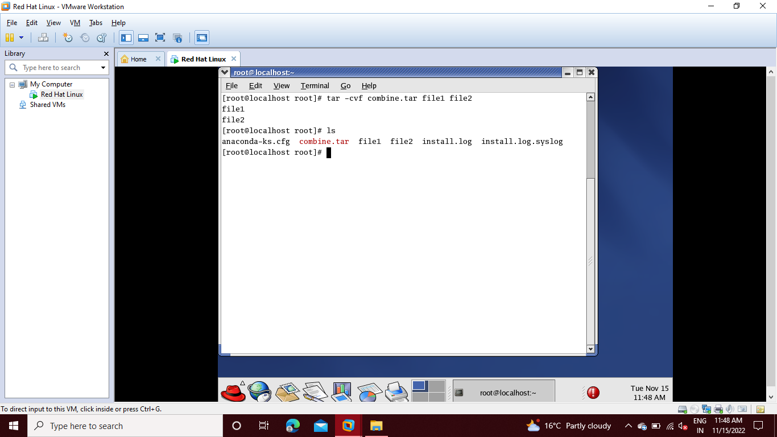

**Ans.2**

Step 1: First we go to terminal and type command **redhat-config-network**

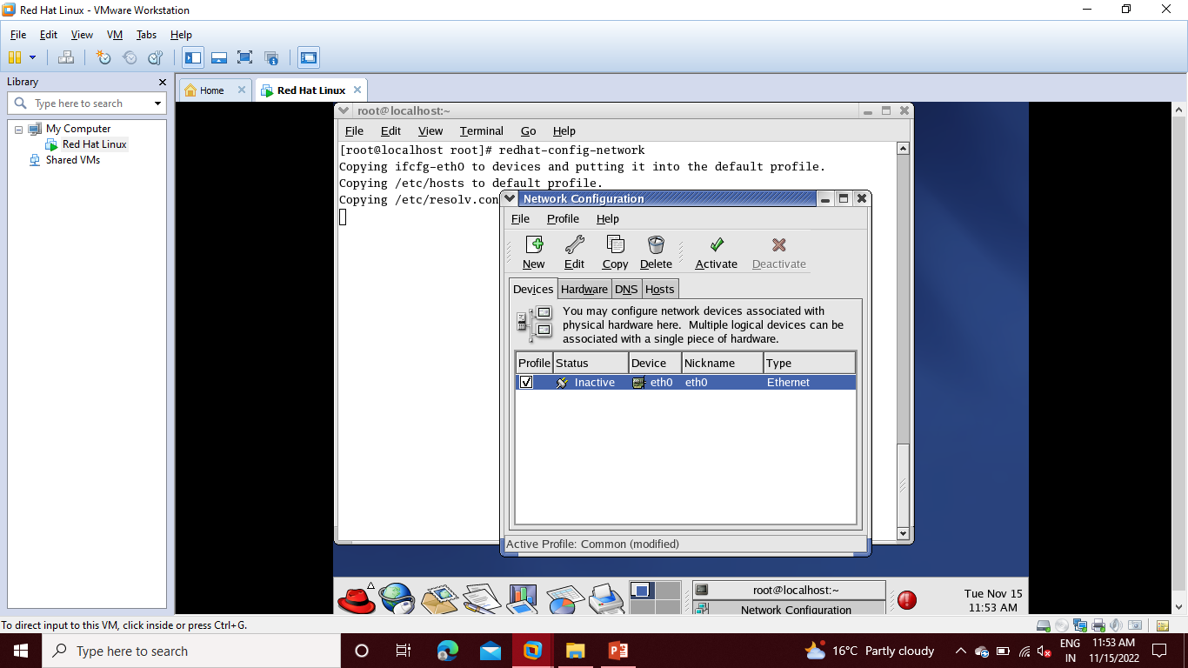

Step 2: Then we go to the network manager and delete the link. And create a new link by clicking on **New** then select **Ethernet connection** and click on **Forward**

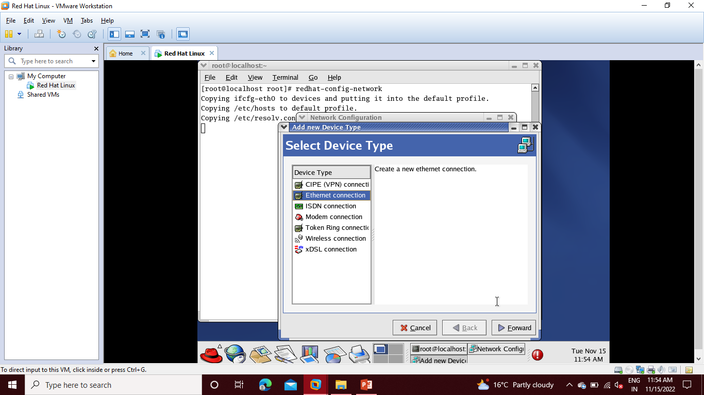

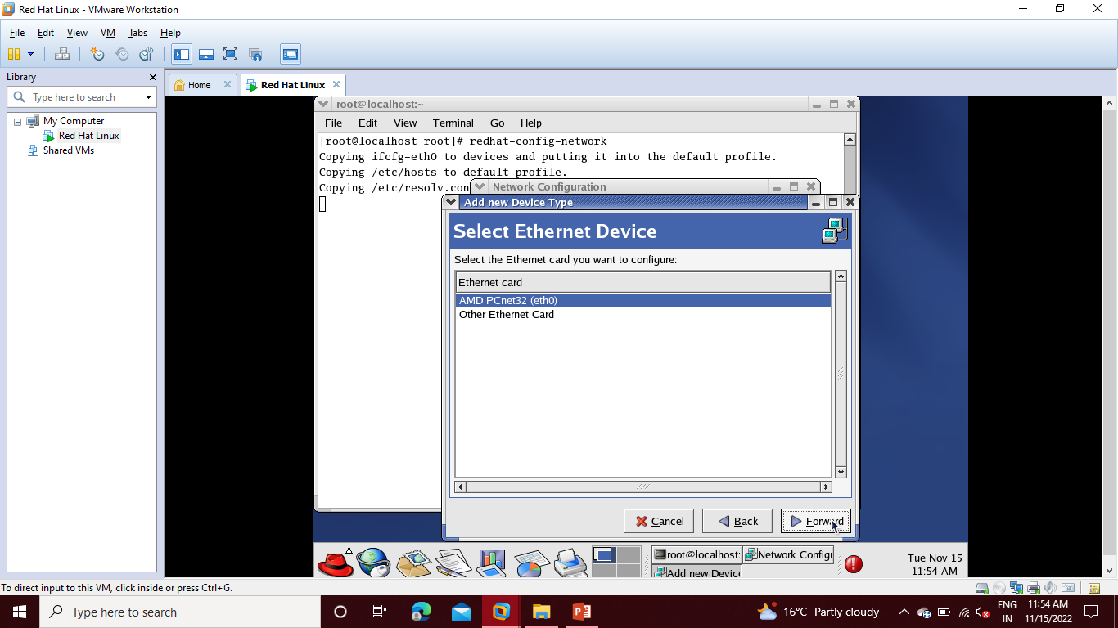Step 3: Then select **Amd PCnet32 (eth0)**  then click on **Forward.**

Step 4: Then select **Statically set IP Addresses** then click on **Forward**.

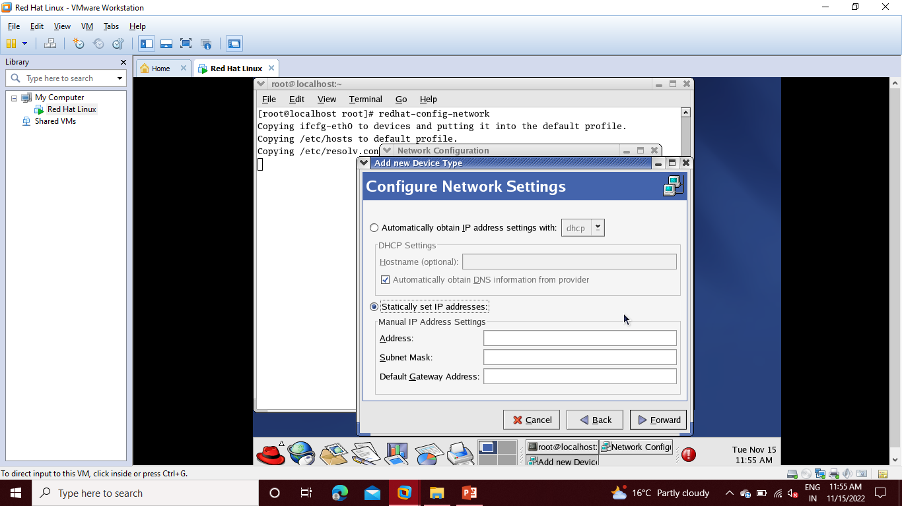

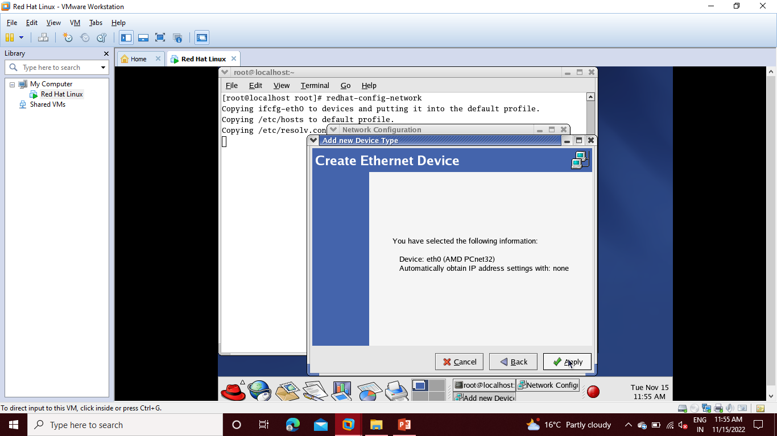Step 5: Click on **Apply**.

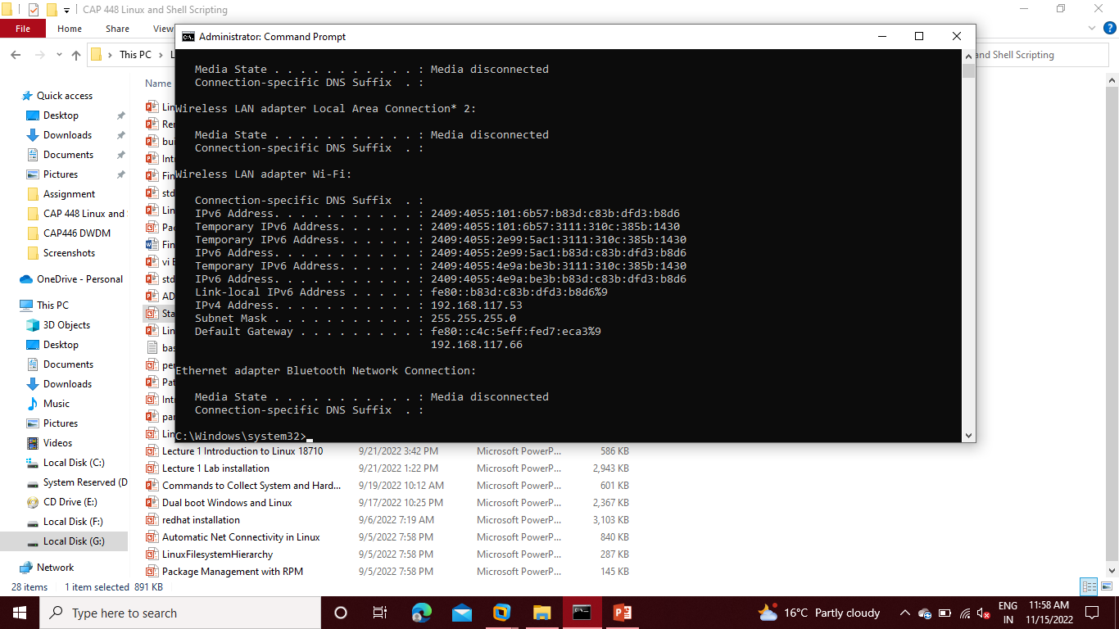Step 6: Then we go to the command prompt and type **ipconfig**.

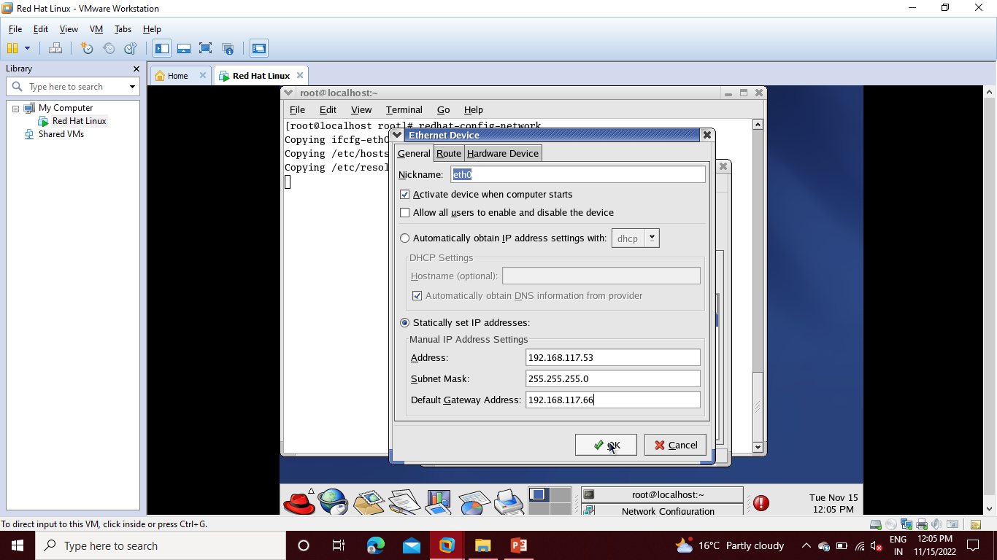Step 7: Fill the details of **Address, Subnet Mask and Default Gateway Address**

Step 8: Then go to command prompt and type **iponfig/all**

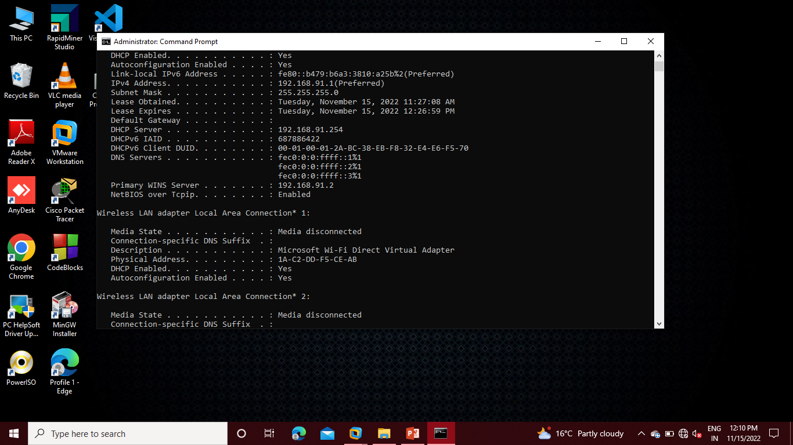

Step 9: Then go to **DNS** and type primary and secondary DNS

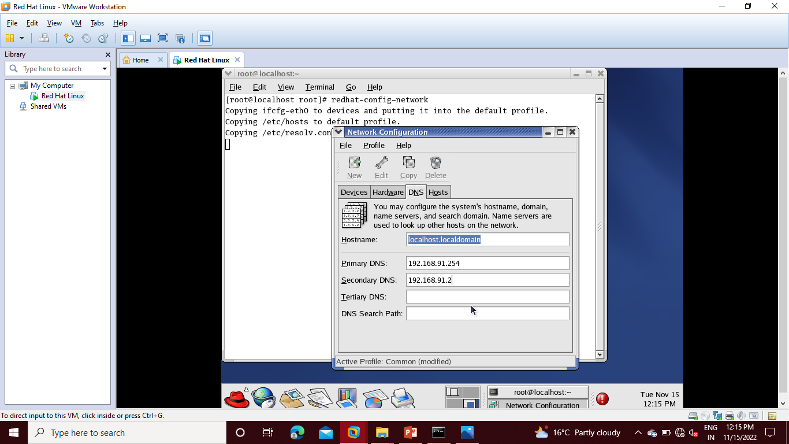

Step 10: Then click on **Yes.**

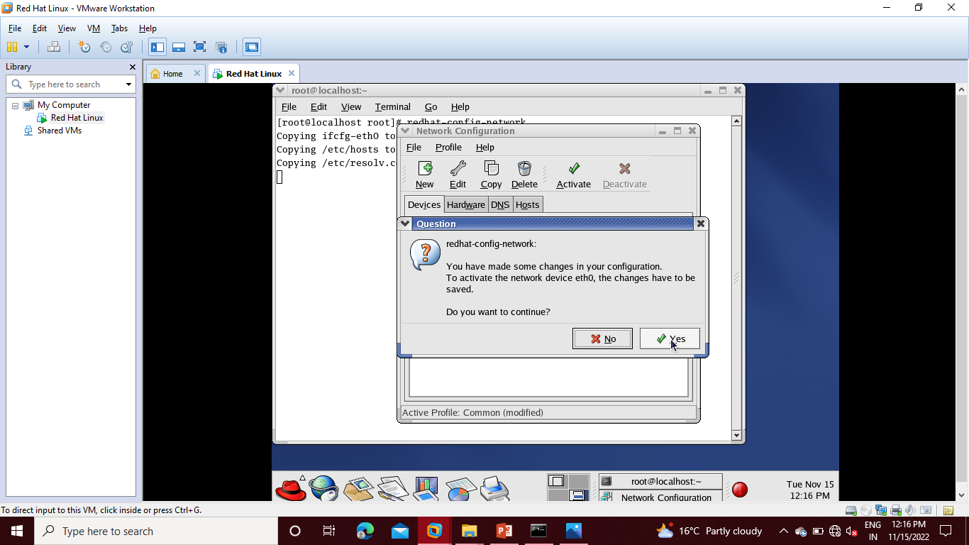

Step 11: Then select the link and click on **Activate.**

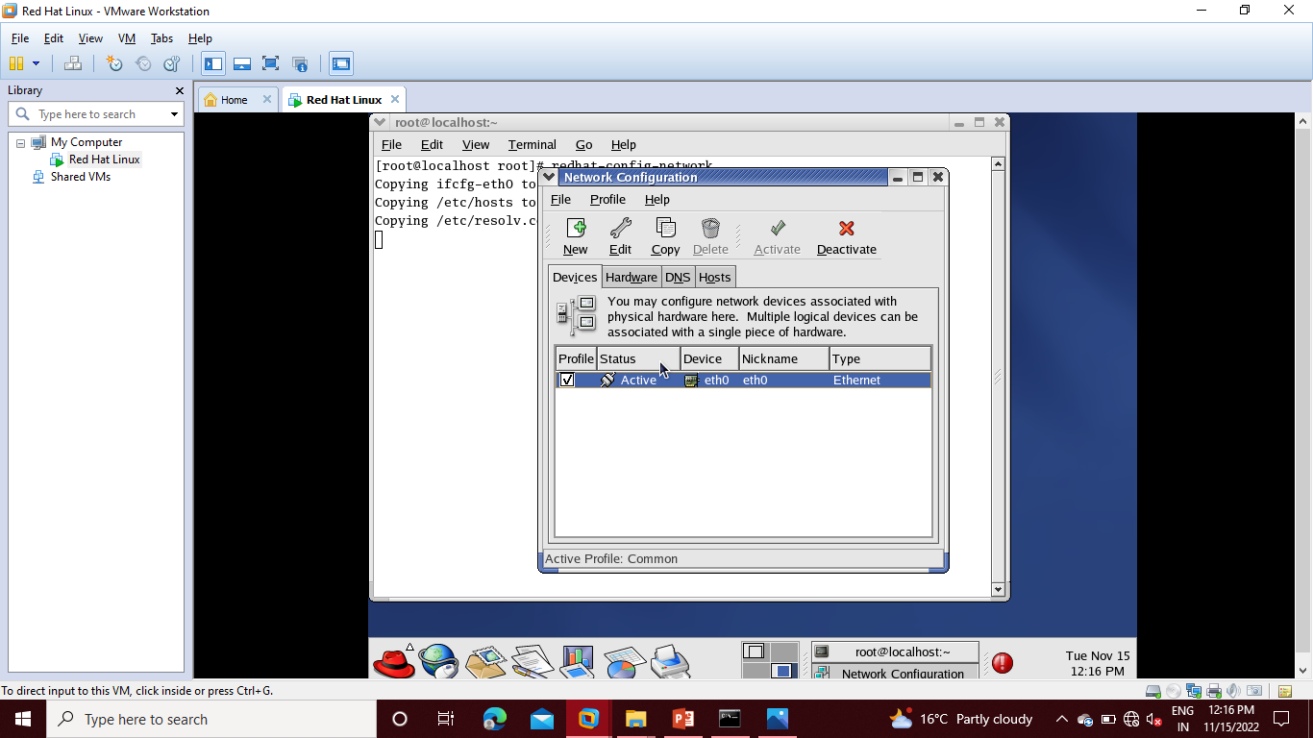

Step 12: Then **Ping any IP address.**

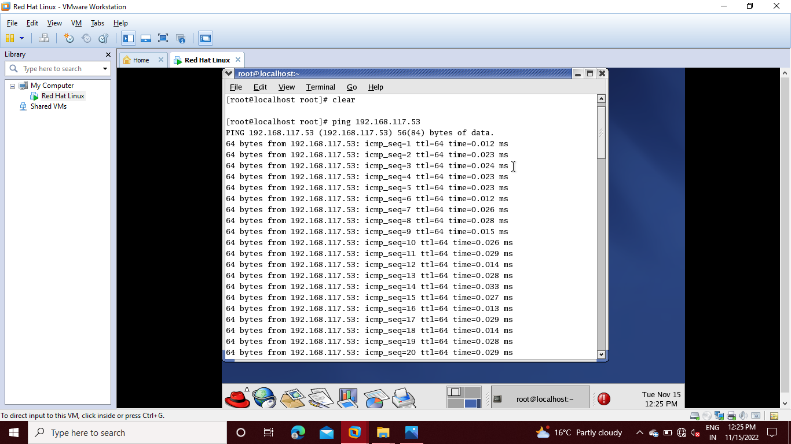

**Ans. 3**

Step 1: For add user admin write the following command :

**useradd admin**

then for setting password we use

**passwd admin**

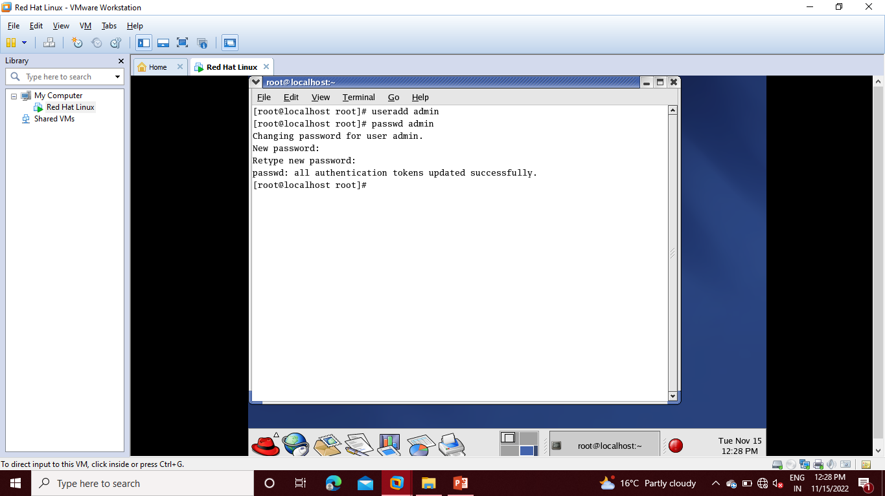

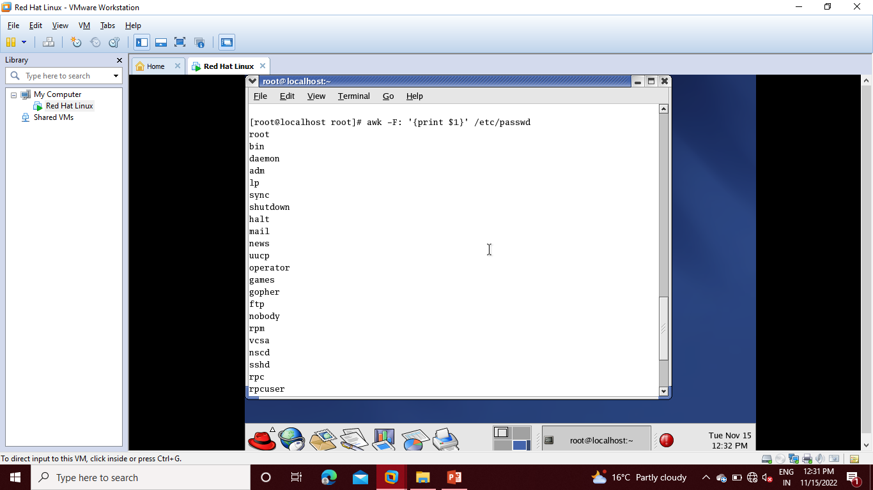Step 2: then check **users by using awk command.**

**Ans.4**

Step 1: For using **Relative Path using pwd**

Step 2: Create two directories **Satyam** and **Mishra**

Step 3: Then change directory using **CD Command**

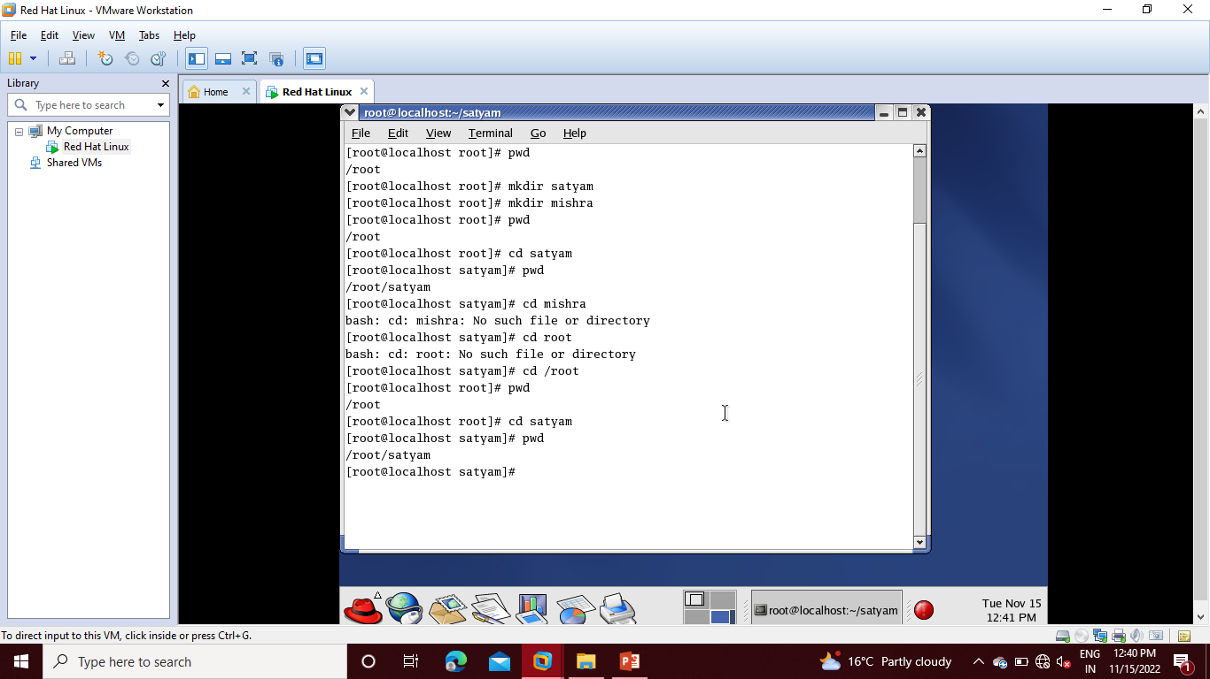

**Ans. 5**

Step1: Go to **VM** then **Removable Devices** and **Connect CD/DVD**

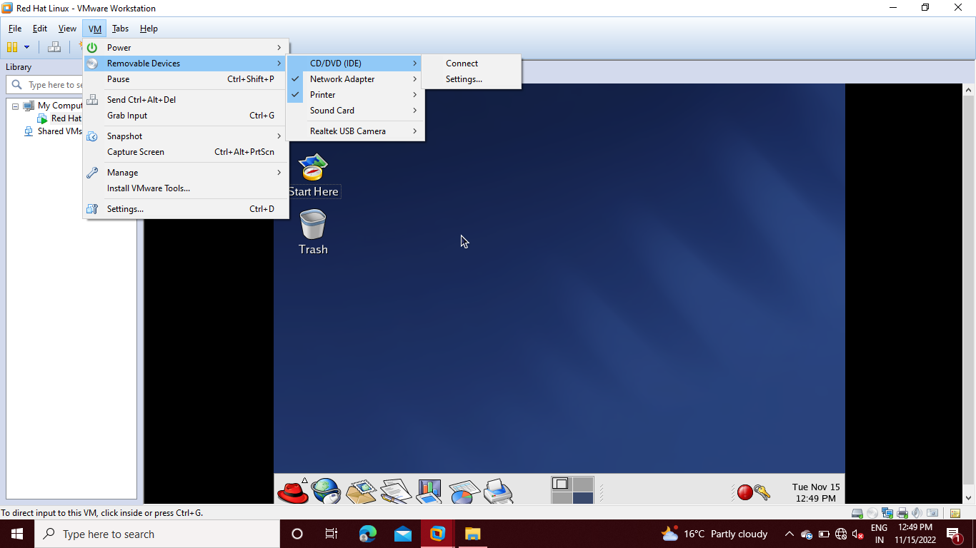

Step 2: Then choose **disc 1** and click on **Open.**

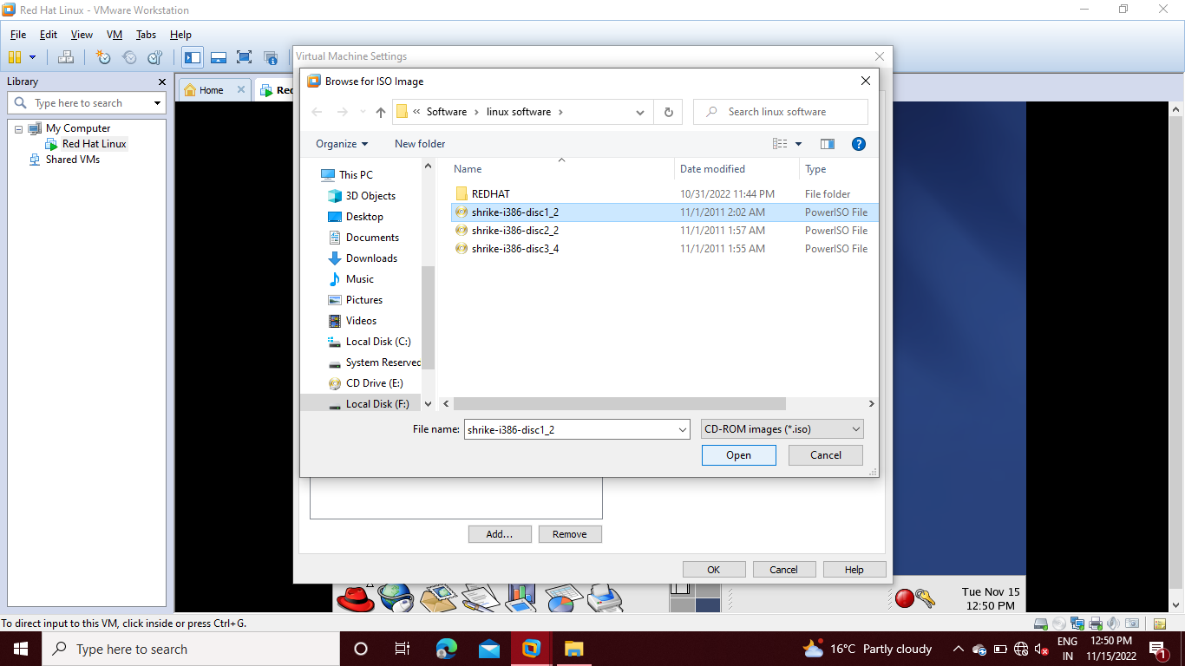

Step 3: The check on **Connected** and click **OK.**

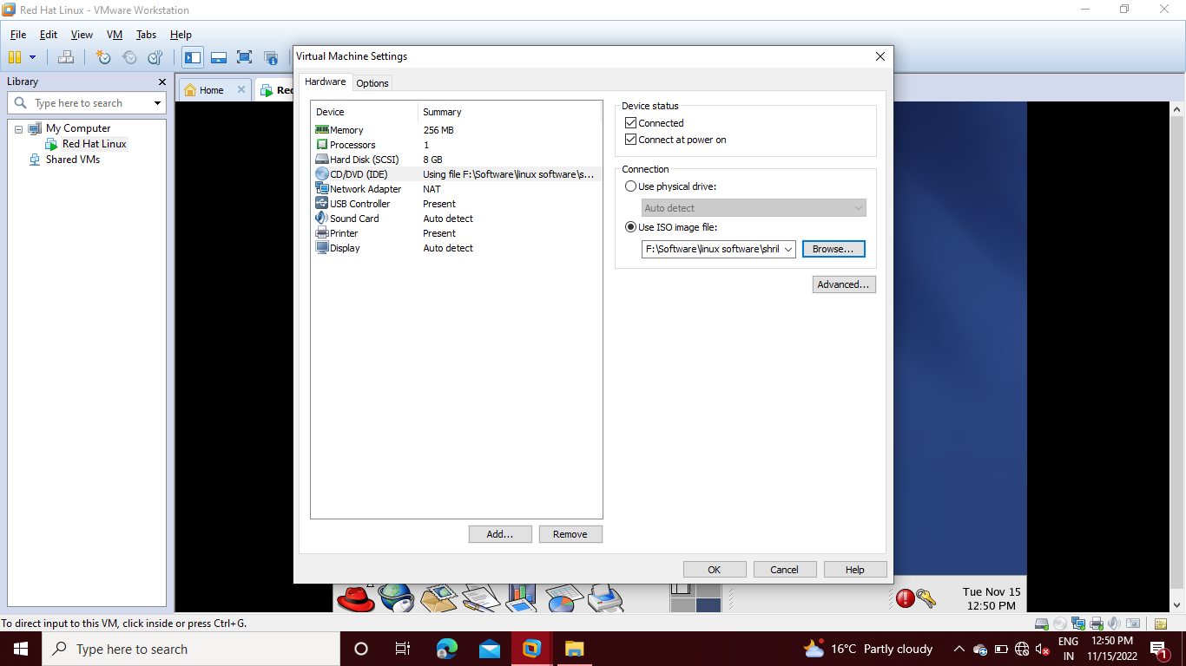

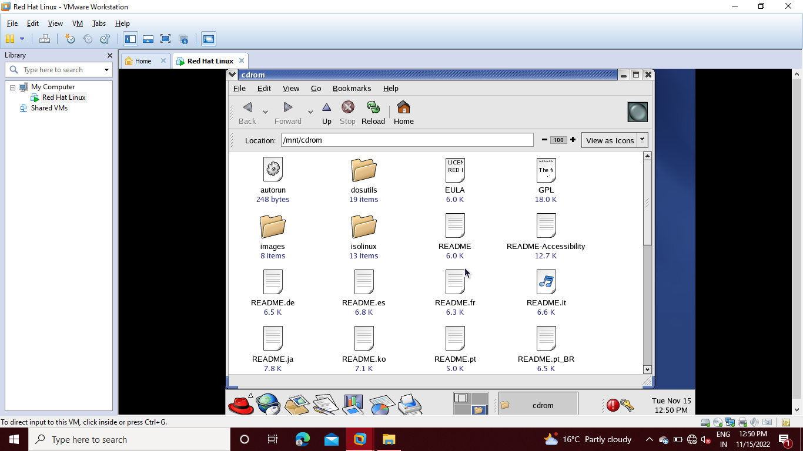

Step 4: Then open **Redhat** directory

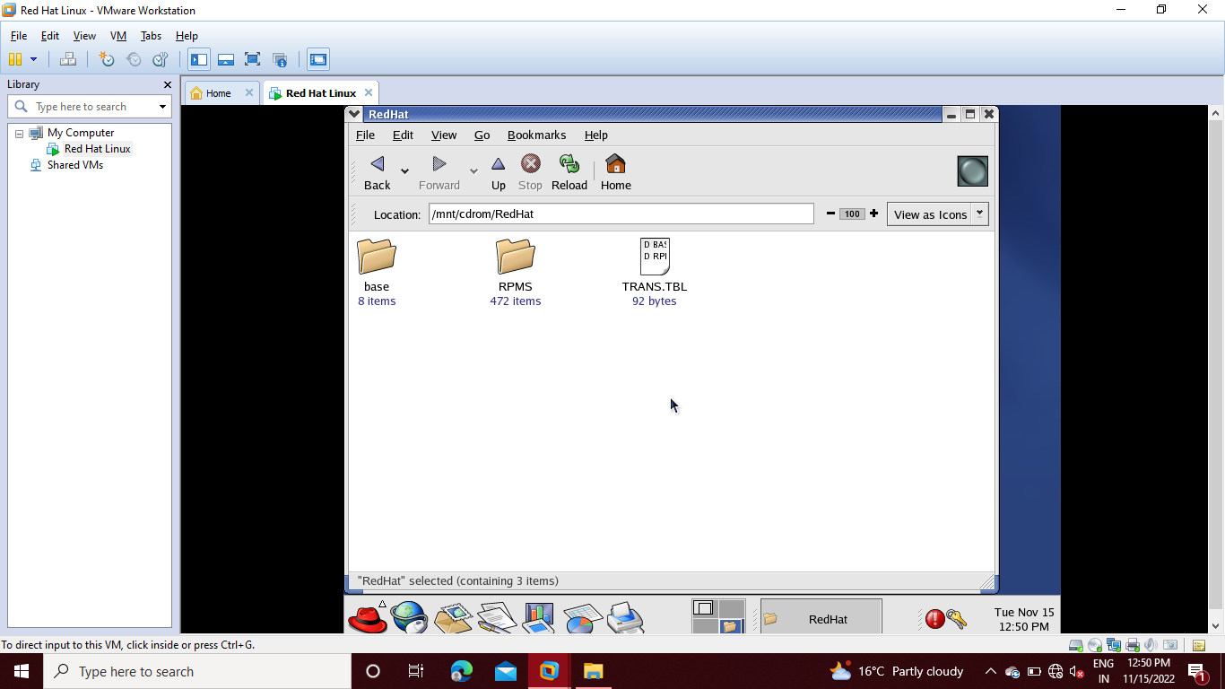

Step 5: Then open **RPMS** directory.

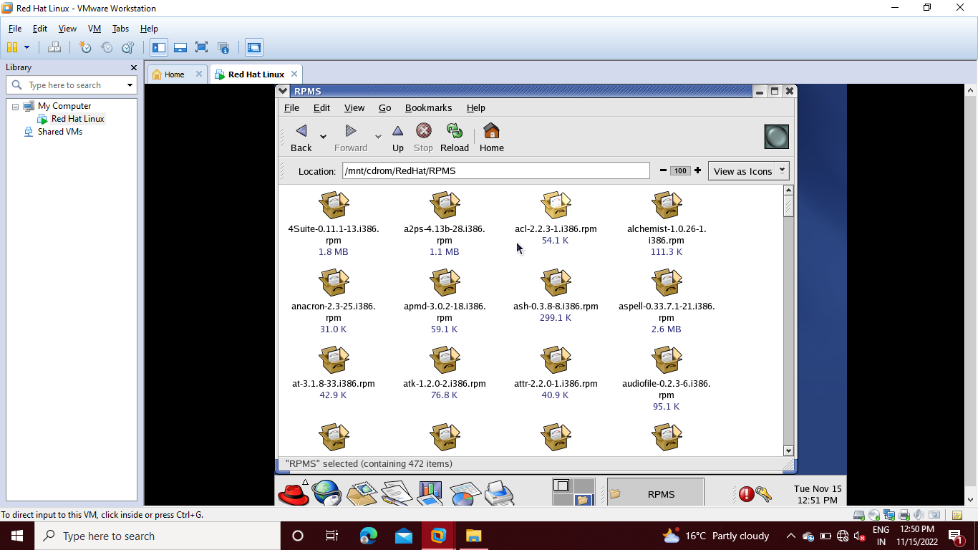

Step 6: Then copy the path and go to terminal and change directory.

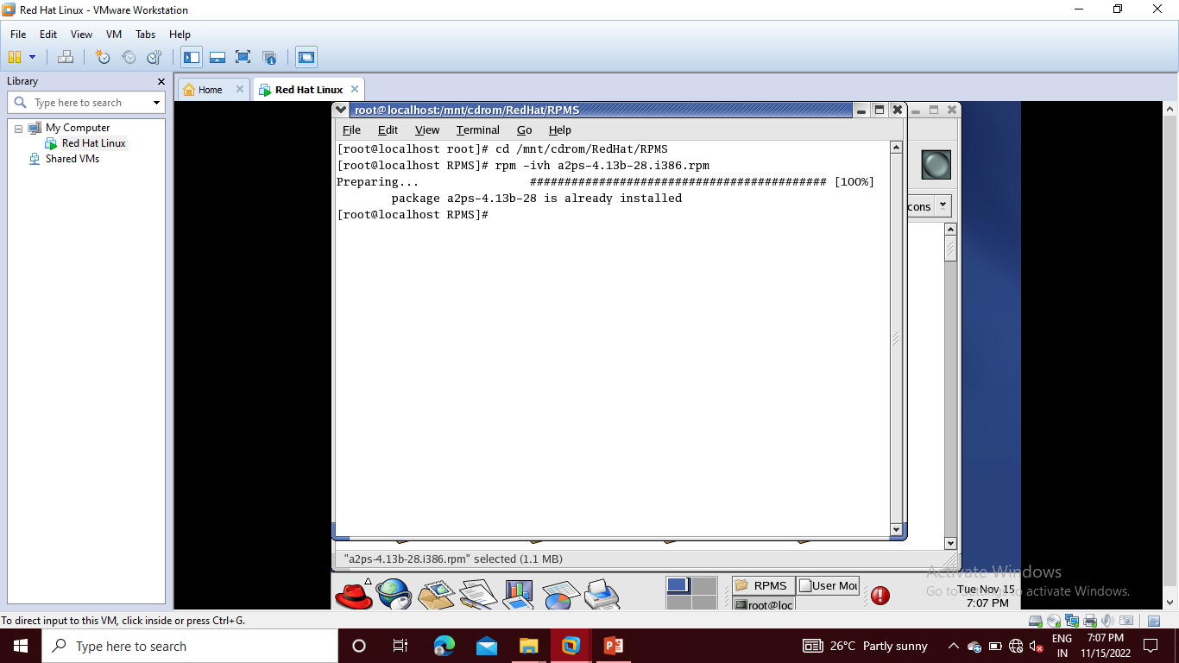Step 7: Then using command **rpm –ivh along with package name.**

Step 8: We saw that the package is already installed so we uninstall it. Using **rpm –e a2ps.**

Step 9: Then we install it using **rpm –ivh** along with package name.

